AC

1. Knowing the elements in the circuit from figure 1a determine the currents with Kirchhoff’s laws and verify the results with power balance.

$$\text{R=}\text{ω}\text{L=}\frac{\text{1}}{\text{ω}\text{C}}\text{=1 Ω;}{\text{u}}_{\text{e1}}\text{= }{\text{u}}_{\text{e2}}\text{=2}\text{sin}\left(\text{ω}\text{t+}\frac{\text{π}}{\text{4}}\right)\text{[V];}{\text{u}}_{\text{e3}}\text{=2}\text{sin}\left(\text{ω}\text{t-}\frac{\text{π}}{\text{4}}\right)\text{[V].}$$

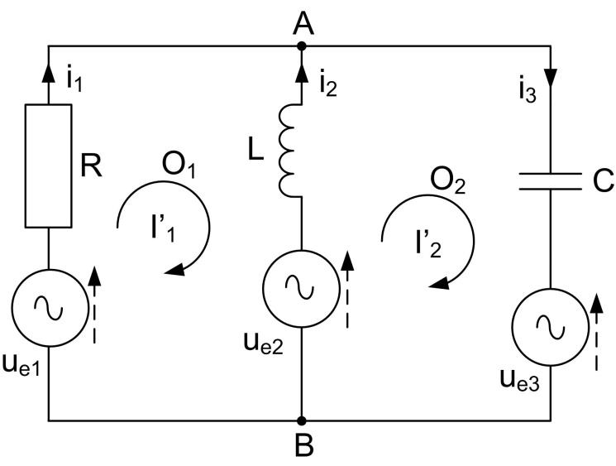

**Fig. 1a**

**Solution**

The complex values of the e.m.f. will be:

$${\underline{\text{U}}}_{\text{e1}}\text{=}{\underline{\text{U}}}_{\text{e2}}=\frac{\text{2}}{\sqrt{\text{2}}}{\text{e}}^{\text{j}\frac{\text{π}}{\text{4}}}\text{=}\frac{2}{\sqrt{2}}\text{(cos }\frac{\text{π}}{\text{4}}\text{+jsin}{\frac{\text{π}}{\text{4}}}\text{)=1+j}\text{;}$$

$${\underline{\text{U}}}_{\text{e3}}\text{=}\frac{\text{2}}{\sqrt{\text{2}}}{\text{e}}^{\text{j(-}\frac{\text{π}}{\text{4}}\text{)}}\text{=}\frac{\text{2}}{\sqrt{\text{2}}}\text{[cos(-}\frac{\text{π}}{\text{4}}\text{)+jsin}{\text{(-}\frac{\text{π}}{\text{4}}\text{)}}\text{=1-j}\text{.}$$

1. **Applying Kirchhoff’s laws method:**

$$\left\{\begin{aligned}\text{A: }{\underline{\text{I}}}_{\text{1}}\text{+}{\underline{\text{I}}}_{\text{2}}\text{=}{\underline{\text{I}}}_{\text{3}}\text{;} \\ {\text{O}}_{\text{1}}\text{: }{\underline{\text{I}}}_{\text{1}}\text{∙}\text{R-}{\underline{\text{I}}}_{\text{2}}\text{∙}\text{j}\text{ω}\text{L=}{\underline{\text{U}}}_{\text{e1}}\text{-}{\underline{\text{U}}}_{\text{e2}}\text{;} \\ {\text{O}}_{\text{2}}\text{: }{\underline{\text{I}}}_{\text{2}}\text{∙}\text{j}\text{ω}\text{L+}{\underline{\text{I}}}_{\text{3}}\text{∙}\frac{\text{1}}{\text{j}\text{ω}\text{C}}\text{=}{\underline{\text{U}}}_{\text{e2}}\text{-}{\underline{\text{U}}}_{\text{e3}}\text{.}\end{aligned}\text{→}\right.\left\{\begin{aligned}{\underline{\text{I}}}_{\text{1}}\text{+}{\underline{\text{I}}}_{\text{2}}\text{=}{\underline{\text{I}}}_{\text{3}}\text{;} \\ {\underline{\text{I}}}_{\text{1}}\text{-}{\text{j}\text{∙}\underline{\text{I}}}_{\text{2}}\text{=0;} \\ {\text{j}\text{∙}\underline{\text{I}}}_{\text{2}}\text{-j}\text{∙}{\underline{\text{I}}}_{\text{3}}\text{=2j.}\end{aligned}\right.\text{→}\left\{\begin{aligned}{\underline{\text{I}}}_{\text{1}}\text{=-2;} \\ {\underline{\text{I}}}_{\text{2}}\text{=2j;} \\ {\underline{\text{I}}}_{\text{3}}\text{=-2+2j.}\end{aligned}\right.$$

The phasor’s diagram is in figure 1b.

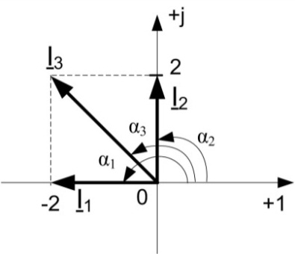

**Fig. 1b**

The instantaneous values of the currents will be: $${\text{i}}_{\text{1}}\text{=2}\sqrt{\text{2}}\text{sin}\left(\text{ω}\text{t+}\text{π}\right)\text{;}$$

$${\text{i}}_{\text{2}}\text{=2}\sqrt{\text{2}}\text{sin}{\text{(}\text{ω}\text{t+}\frac{\text{π}}{\text{2}}\text{);}}$$

$${\text{i}}_{\text{3}}\text{=4}\text{sin}{\text{(}\text{ω}\text{t+}\frac{\text{3π}}{\text{4}}\text{).}}$$

**b. Power balance:**

The complex powers supplied by the sources:

$${\underline{\text{S}}}_{\text{G}}\text{= }{\underline{\text{U}}}_{\text{e1}}\text{∙}{\underline{\text{I}}}_{\text{1}}^{\text{*}}\text{+}{\underline{\text{U}}}_{\text{e2}}\text{∙}{\underline{\text{I}}}_{\text{2}}^{\text{*}}\text{-}{\underline{\text{U}}}_{\text{e3}}\text{∙}{\underline{\text{I}}}_{\text{3}}^{\text{*}}\text{=}\left(\text{1+j}\right)\left(\text{-2}\right)\text{+(1+j)}\left(\text{-2j}\right)\text{-(1-j)}\left(\text{-2-2j}\right)\text{=4-4j}\text{;}$$

$${\text{P}}_{\text{G}}\text{=4 W; }{\text{Q}}_{\text{G}}\text{=-4 VAr; }{\text{S}}_{\text{G}}\text{=4}\sqrt{\text{2}}\text{ VA. }$$

The complex powers absorbed by the consumers:

$${\underline{\text{S}}}_{\text{Z}}\text{=}{\text{P}}_{\text{Z}}\text{+j}{\text{Q}}_{\text{Z}}.$$

$${\text{P}}_{\text{Z}}\text{=R}\text{∙}{\text{I}}_{\text{1}}^{\text{2}}\text{=1}\text{∙}\text{4=4 W}\text{;}$$

$${\text{Q}}_{\text{Z}}\text{=0}\text{∙}{\text{I}}_{\text{1}}^{\text{2}}\text{+}\text{ω}\text{L}\text{∙}{\text{I}}_{\text{2}}^{\text{2}}\text{-}\frac{\text{1}}{\text{ω}\text{C}}\text{∙}{\text{I}}_{\text{3}}^{\text{2}}\text{=1}\text{∙}\text{4-1}\text{∙}\text{8=-4 VAr.}$$

1. Knowing the elements in the circuit from figure 2a determine the currents with Kirchhoff’s laws and verify the results with power balance. Determine also uAC.

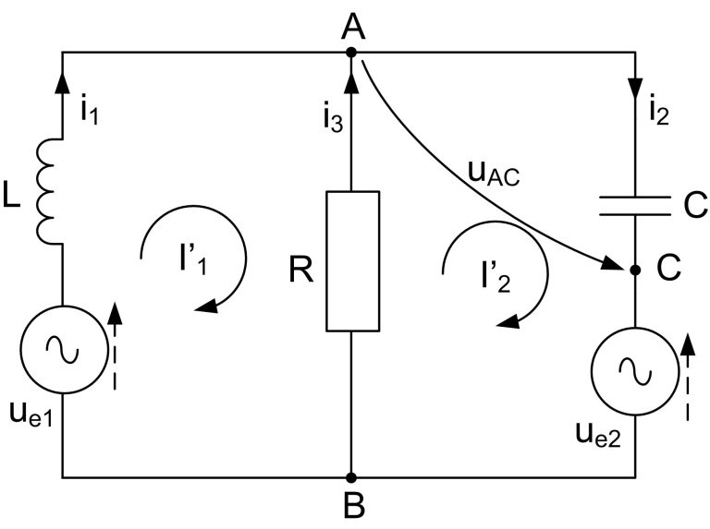

**Fig. 2a**

**Solution**

$$\text{ω}\text{L=100}\text{π}\text{∙}\frac{\text{1}}{\text{10π}}\text{=10Ω;}$$

$$\frac{\text{1}}{\text{ω}\text{C}}\text{=}\frac{\text{1}}{\text{100π}}\text{∙}\frac{\text{1000π}}{\text{1}}\text{=}\text{10Ω;}$$

$$\text{cos}{\text{α}\text{=}\text{sin}\left(\text{α}\text{+}\frac{\text{π}}{\text{2}}\right)}\text{.}$$

The complex values of the e.m.f. will be:

$${\text{u}}_{\text{e1}}\text{=200}\text{cos}\left(\text{ω}\text{t+}\frac{\text{5π}}{\text{4}}\right)\text{=}\text{200sin}\left(\text{ω}\text{t+}\frac{\text{5π}}{\text{4}}\text{+}\frac{\text{π}}{\text{2}}\right)\text{=}\text{200sin}\left(\text{ω}\text{t+}\frac{\text{7π}}{\text{4}}\right)\text{;}$$

$${\underline{\text{U}}}_{\text{e1}}=\frac{\text{200}}{\sqrt{\text{2}}}{\text{e}}^{\text{j}\frac{\text{7π}}{\text{4}}}\text{=}\frac{\text{200}}{\sqrt{\text{2}}}\text{(cos}\frac{\text{7π}}{\text{4}}\text{+jsin}{\frac{\text{7π}}{\text{4}}}\text{)=}\frac{\text{200}}{\sqrt{\text{2}}}\left(\frac{\sqrt{\text{2}}}{\text{2}}\text{-j}\frac{\sqrt{\text{2}}}{\text{2}}\right)\text{=100(1-j)}\text{;}$$

$$\text{cos}\frac{\text{7π}}{\text{4}}\text{=cos(2π-}\frac{\text{π}}{\text{4}}\text{)=+cos}\frac{\text{π}}{\text{4}}\text{=}\frac{\sqrt{\text{2}}}{\text{2}};$$

$$\text{sin}\frac{\text{7π}}{\text{4}}\text{=sin(2π-}\frac{\text{π}}{\text{4}}\text{)=-sin}\frac{\text{π}}{\text{4}}\text{=-}\frac{\sqrt{\text{2}}}{\text{2}};$$

$${\underline{\text{U}}}_{\text{e2}}=\frac{\text{100}\sqrt{\text{2}}}{\sqrt{\text{2}}}{\text{e}}^{\text{j0}}\text{=100(cos 0+jsin}{\text{0)}}\text{=100.}$$

1. **Applying Kirchhoff’s laws method:**

$$\left\{\begin{aligned}\text{A: }{\underline{\text{I}}}_{\text{1}}\text{+}{\underline{\text{I}}}_{\text{2}}\text{=}{\underline{\text{I}}}_{\text{3 }}\text{;} \\ {\text{O}}_{\text{1}}\text{: }{\underline{\text{I}}}_{\text{1}}\text{∙}\text{j}\text{ω}\text{L-}{\underline{\text{I}}}_{\text{3}}\text{∙}\text{R=}{\underline{\text{U}}}_{\text{e1}}\text{;} \\ {\text{O}}_{\text{2}}\text{: }{\underline{\text{I}}}_{\text{3}}\text{∙}\text{R+}{\underline{\text{I}}}_{\text{2}}\text{∙}\frac{\text{1}}{\text{j}\text{ω}\text{C}}\text{=-}{\underline{\text{U}}}_{\text{e2}}\text{.}\end{aligned}\text{→}\right.\left\{\begin{aligned}{\underline{\text{I}}}_{\text{1}}\text{+}{\underline{\text{I}}}_{\text{2}}\text{=}{\underline{\text{I}}}_{\text{3}}\text{;} \\ \text{10j}\text{∙}{\underline{\text{I}}}_{\text{1}}\text{-10}\text{∙}{\underline{\text{I}}}_{\text{3}}\text{=100(1-j);} \\ \text{10}\text{∙}{\underline{\text{I}}}_{\text{3}}\text{-10j}\text{∙}{\underline{\text{I}}}_{\text{2}}\text{=-100.}\end{aligned}\right.\text{→}\left\{\begin{aligned}{\underline{\text{I}}}_{\text{1}}\text{+}{\underline{\text{I}}}_{\text{2}}\text{=}{\underline{\text{I}}}_{\text{3}}\text{;} \\ \text{j}\text{∙}{\underline{\text{I}}}_{\text{1}}\text{-}{\underline{\text{I}}}_{\text{3}}\text{=10(1-j);} \\ {\underline{\text{I}}}_{\text{3}}\text{-j}\text{∙}{\underline{\text{I}}}_{\text{2}}\text{=-10.}\end{aligned}\right.$$

$$\text{→}\left\{\begin{aligned}{\underline{\text{I}}}_{\text{1}}\text{=-10-20j;} \\ {\underline{\text{I}}}_{\text{2}}\text{=-20j;} \\ {\underline{\text{I}}}_{\text{3}}\text{=10.}\end{aligned}\right.$$

The phasor’s diagram is in figure 2b.

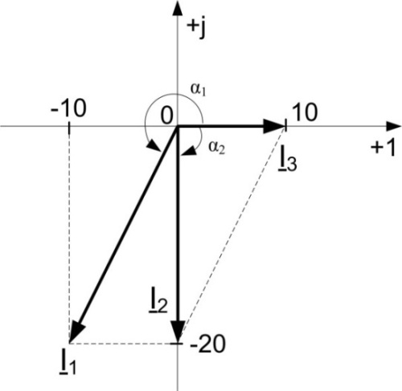

**Fig. 2b**

The instantaneous values of the currents :

$${\text{i}}_{\text{1}}\text{=10}\sqrt{\text{10}}\text{sin}{\text{(}\text{ω}\text{t+}\text{π}\text{+arctg 2)}}\text{[A];} \\ {\text{i}}_{\text{2}}\text{=20}\sqrt{\text{2}}\text{sin}{\text{(}\text{ω}\text{t-}\frac{\text{π}}{\text{2}}\text{) [A]}}\text{;}$$

$${\text{i}}_{\text{3}}\text{=10}\sqrt{\text{2}}\text{sin}{\text{ω}\text{t [A].}}$$

**Power balance:**

The complex powers supplied by souces:

$${\underline{\text{S}}}_{\text{G}}\text{= }{\underline{\text{U}}}_{\text{e1}}\text{∙}{\underline{\text{I}}}_{\text{1}}^{\text{*}}\text{-}{\underline{\text{U}}}_{\text{e2}}\text{∙}{\underline{\text{I}}}_{\text{2}}^{\text{*}}\text{=100}\left(\text{1-j}\right)\left(\text{-10+20j}\right)\text{-100}\text{∙}\text{20j =}$$

$$\text{=1000(-1+j+2j+2-2j)=1000(1+j)}\text{;}$$

$${\text{P}}_{\text{G}}\text{=1000 W; }{\text{Q}}_{\text{G}}\text{=1000 VAr; }{\text{S}}_{\text{G}}\text{=1000}\sqrt{\text{2}}\text{ VA. }$$

The complex powers absorbed by the comsumers:

$${\underline{\text{S}}}_{\text{Z}}\text{=}{\text{P}}_{\text{Z}}\text{+j}{\text{Q}}_{\text{Z}}.$$

$${\text{P}}_{\text{Z}}\text{=R}\text{∙}{\text{I}}_{\text{3}}^{\text{2}}\text{=10}\text{∙}{\text{10}}^{\text{2}}\text{=1000 W}\text{;}$$

$${\text{Q}}_{\text{Z}}\text{=}\text{ω}\text{L}\text{∙}{\text{I}}_{\text{1}}^{\text{2}}\text{-}\frac{\text{1}}{\text{ω}\text{C}}\text{∙}{\text{I}}_{\text{2}}^{\text{2}}\text{=10}\text{∙}{\text{(10}\sqrt{\text{5}}\text{)}}^{\text{2}}\text{-10}\text{∙}{\text{20}}^{\text{2}}\text{=1000 VAr.}$$

The voltage ${\underline{\text{U}}}_{\text{AC}}$ can be computed by applying the second Kirchhoff’s law in the loop ACA:

$${\underline{\text{U}}}_{\text{AC}}\text{=}{\underline{\text{Z}}}_{\text{AC}}\text{∙}{\underline{\text{I}}}_{\text{2}}\text{=-}\text{10j(-20j)=-200}\text{.}$$

The instantaneous value: $${\text{u}}_{\text{AC}}\text{=200}\sqrt{\text{2}}\text{sin}{\text{(}\text{ω}\text{t+}\text{π}\text{) [V].}}$$